Double Dapple Dachshund and Genetic Risk

Dappling is a coat pattern found in the Dachshund dog breed. This dappling pattern is a splotchy multi-color pattern in the dog coat. The dappling can be all over or in a very small area such as an ear or spot on the chest. There is a very large risk in breeding two dapples together which will result in what we call double dapples. There are extreme risks in breeding dapples and a good breeder will not risk the health of their pups in this way.

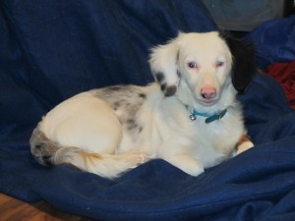
A deaf and blind in one eye double dapple dachshund. Notice the unsymmetrical markings, one ear white with dappling and one solid black ear. He is a puppy mill survivor.
The risks in breeding dapples include birth defects such as blind, deaf or both and microphthalmia (an abnormally small eye). Sometimes this overlapping dapple gene can even cause missing eyes and/or ears. However, a double dapple puppy can be born with no deformities at all. Many believe that if the dog has blue eyes they are a double dapple. This is incorrect because some dapples have blue eyes and some double dapples do not have blue eyes.
Because of the beautiful pattern of double dapples, some people take the risk of breeding the dogs because of the price for which they can sell the puppies. This is such a sad thing because many of the pups that are born with birth defects end up being killed, sent to shelters or sold to people unaware that the pup is blind/deaf. You can only hope that those that bought a double dapple and later find out they are blind/deaf will still love them and take care of them.
Offspring from double dapple (merle x merle) and dapple x piebald breedings can be born:
Deaf, partially deaf, blind, partially blind, with no eyes or sterile. A breeder should never knowingly breed health problems into a gene pool and they should never breed dapple to dapple or dapple to piebald.

